**Introduction to IDE and Introduction to C++**

**LAB # 1**



**Spring 2019**

**CSE102L Computer Programming Lab**

Submitted by: **SHAH RAZA**

Registration No.: **18PWCSE1658**

Class Section: **B**

“On my honor, as student of University of Engineering and Technology, I have neither given nor received unauthorized assistance on this academic work.”

Student Signature: ______________

Submitted to:

**Engr. Madiha Sher**

February 19, 2019

Department of Computer Systems Engineering

University of Engineering and Technology, Peshawar

**Objectives:**

* To be able to install and use Code::Blocks IDE for compiling C++ programs
* To be familiar with syntax and structure of C++ programming

**TASK #1:**

**Title:**

Write a program to display your name on console.

**Problem Analysis:**

The problem is to display my name on console. This can be done using a single cout statement. During the processing or calculation phase, we don’t need any parameters (variables) for this problem.

**Algorithm:**

1. Start
2. Display “My name is Shah Raza”
3. Stop

**Flowchart:**

Start

Print “My name is Shah Raza”

Using cout

Stop

**Code:**

/*Following code is written and compiled in Code::Blocks IDE*/

#include<iostream> /* library for writing the output to console window*/

int main ()

{ //start the program

cout<<”My name is Shah Raza”;

return 0;

}

**Output (Compilation, Debugging & Testing):**

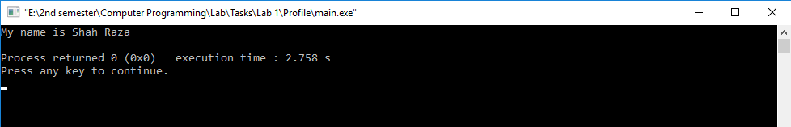

**TASK # 2:**

**Title:**

Write a program to add two numbers (5&7) and display its sum.

**Problem Analysis:**

The problem is to calculate the sum of two numbers having its inputs parameters identified as: A (integer type) and B (integer type). The output of the program is to display the sum; hence the output parameter is identified as sum (integer type). During the processing or calculation phase, we don’t need any extra parameters (variables) for this problem.

The sum of the numbers is the addition of its A and B, hence the mathematical formula to calculate sum is:

sum = A + B

|  |  |  |  |
| --- | --- | --- | --- |
| Input variables | Processing variables/calculations | Output variables | Necessary header files/functions/macros |
| A (int)  B (int) | sum = A+B | sum (int) | iostream.h |

**Algorithm:**

1. Start
2. Declare variables: A (int), B(int)
3. Assign values to variables: A=5, B=7
4. Calculate the sum as: sum=A+B
5. Display the sum
6. Stop

**Flowchart:**

### **Code:**

/*Following code is written and compiled in Code::Blocks IDE*/

#include<iostream> /* library for writing the output to console window*/

int main ()

{ //start the program

int A,B,sum;

//variables declaration

A=5;B=7;

//assign value to variables

sum=A+B;

/*calculation using mathematical formula*/

cout << "The Sum of the two numbers is: ";

cout << sum;

//display the sum

return 0;

//end the main program

}

Start

Declare memory for:

A, B

Initialize input variables:

A=5; B=7

Calculate sum using formula:

Sum=A+B

Print sum using cout

Stop

**Output (Compilation, Debugging & Testing):**

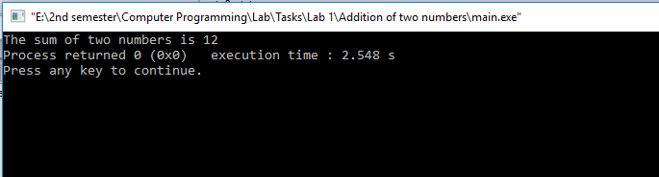

**TASK # 3:**

**Title:**

Write a program to multiply two numbers (10&8) and display its product.

**Problem Analysis:**

The problem is to calculate the Product of two numbers having its inputs parameters identified as: A (integer type) and B (integer type). The output of the program is to display the Product; hence the output parameter is identified as Product (integer type). During the processing or calculation phase, we don’t need any extra parameters (variables) for this problem.

The Product of the numbers is the multiplication of A and B, hence the mathematical formula to calculate Product is:

Product = A*B

|  |  |  |  |
| --- | --- | --- | --- |
| Input variables | Processing variables/calculations | Output variables | Necessary header files/functions/macros |
| A (int)  B (int) | Product = A*B | Product (int) | iostream.h |

**Algorithm:**

1. Start
2. Declare variables: A (int), B(int)
3. Assign values to variables: A=10, B=8
4. Calculate the Product as: Product=A+B
5. Display the Product
6. Stop

**Flowchart:**

Start

Declare memory for:

A, B

Initialize input variables:

A=10; B=8;

Calculate Product using formula:

Product=A*B

Print Product using cout

Stop

### **Code:**

/*Following code is written and compiled in Code::Blocks IDE*/

#include<iostream> /* library for writing the output to console window*/

int main ()

{ //start the program

int A,B,Product;

//variables declaration

A=10;B=8;

//assign value to variables

Product=A*B;

/*calculation using mathematical formula*/

cout << "The Product of the two numbers is: ";

cout << Product;

//display the Product

return 0;

//end the main program

}

**Output (Compilation, Debugging & Testing):**

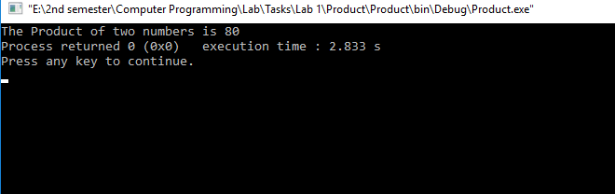

**TASK # 4:**

**Title:**

Write a program to calculate area of a circle having its radius (r = 5).

**Problem Analysis:**

The problem is to calculate the area of a circle having its inputs parameters identified as: r (integer type). The output of the program is to display the area of circle; hence the output parameter is identified as Area (float type). During the processing or calculation phase, we don’t need any extra parameters (variables) for this problem.

The area of the circle is the multiplication of  **π** and r2, hence the mathematical formula to calculate area is:

Area = 3.14*r*r

|  |  |  |  |
| --- | --- | --- | --- |
| Input variables | Processing variables/calculations | Output variables | Necessary header files/functions/macros |
| r (int) | Area=3.14*r*r | Area (float) | iostream.h |

**Algorithm:**

1. Start
2. Declare variables: r (int)
3. Assign values to variables: r=5
4. Calculate the area as: Area=3.14*r*r
5. Display the Area
6. Stop

### **Code:**

/*Following code is written and compiled in Code::Blocks IDE*/

#include<iostream> /* library for writing the output to console window*/

int main ()

{ //start the program

int r;

float Area;

//variables declaration

r=5;

//assign value to variables

Area=3.14*r*r;

/*calculation using mathematical formula*/

cout << "The Area of the circle is: ";

cout << Area;

//display the Area

return 0;

//end the main program

}

**Flowchart:**

Start

Declare memory for:

r

Initialize input variables:

r=5

Calculate area using formula:

Area=3.14*r*r

Print Area using cout

Stop

**Output (Compilation, Debugging & Testing):**

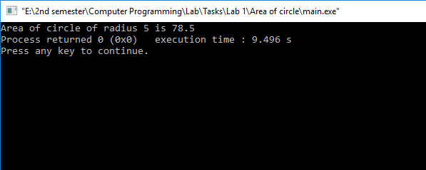

**TASK # 5:**

**Title:**

Write a program to calculate area of an ellipse having its axes (minor=4cm, major=6cm).

**Problem Analysis:**

The problem is to calculate the area of an ellipse having its inputs parameters identified as: minor (integer type) and major (integer type). The output of the program is to display the area of ellipse; hence the output parameter is identified as Area (float type). During the processing or calculation phase, we don’t need any extra parameters (variables) for this problem.

The area of the ellipse is the multiplication of  **π**, minor and major, hence the mathematical formula to calculate area is:

Area = 3.14*minor*major

|  |  |  |  |
| --- | --- | --- | --- |
| Input variables | Processing variables/calculations | Output variables | Necessary header files/functions/macros |
| minor (int)  major (int) | Area=3.14*minor*major | Area (float) | iostream.h |

**Algorithm:**

1. Start
2. Declare variables: minor (int), major (int)
3. Assign values to variables: minor=4; major=6;
4. Calculate the area as: Area=3.14*minor*
5. Display the Area
6. Stop

### **Code:**

/*Following code is written and compiled in Code::Blocks IDE*/

#include<iostream> /* library for writing the output to console window*/

int main ()

{ //start the program

int minor,major;

float Area;

//variables declaration

minor=4;major=6;

//assign value to variables

Area=3.14*minor*major;

/*calculation using mathematical formula*/

cout << "The Area of the ellipse is: ";

cout << Area;

//display the Area

return 0;

//end the main program

}

**Flowchart:**

Start

Declare memory for:

minor, major

Initialize input variables:

minor=4; major=6;

Calculate area using formula:

Area=3.14*minor*major

Print Area using cout

Stop

**Output (Compilation, Debugging & Testing):**

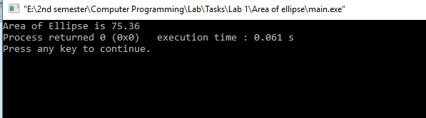

**TASK # 6:**

**Title:**

Write a program to calculate simple interest for a given P=4000, T=2, R=5.5. (I = P*T*R/100).

**Problem Analysis:**

The problem is to calculate the simple interest having its inputs parameters identified as: P (integer type), T (integer type) and R (float type). The output of the program is to display the simple interest; hence the output parameter is identified as I (float type). During the processing or calculation phase, we don’t need any extra parameters (variables) for this problem.

The simple interest is the multiplication of  P, T and R divided by 100, hence the mathematical formula to calculate simple interest is:

I = (P*T*R)/100

|  |  |  |  |
| --- | --- | --- | --- |
| Input variables | Processing variables/calculations | Output variables | Necessary header files/functions/macros |
| P (int)  T (int)  R (float) | I=(P*T*R)/100 | I (float) | iostream.h |

**Algorithm:**

1. Start
2. Declare variables: P (int), T (int), R (float)
3. Assign values to variables: P=4000; T=2; R=5.5;
4. Calculate the Interest as: I=(P*T*R)/100
5. Display the Interest
6. Stop

**Flowchart:**

Start

Declare memory for:

P, T, R

Initialize input variables:

P=4000; T=2; R=5.5;

Calculate Interest using formula:

I=(P*T*R)/100

Print Interest using cout

Stop

### **Code:**

/*Following code is written and compiled in Code::Blocks IDE*/

#include<iostream> /* library for writing the output to console window*/

int main ()

{ //start the program

int P,T;

float R,I;

//variables declaration

P=4000;T=2;R=5.5;

//assign value to variables

I=(P*T*R)/100;

/*calculation using mathematical formula*/

cout << "The Simple interest is: ";

cout << I;

//display the interest

return 0;

//end the main program

}

**Output (Compilation, Debugging & Testing):**

